Registers / CPU Cache – Memory Organization
# Source: AI Source: Provided by: [Data Path: Persons Table -> ID Column: 1, Name_En Column: Motasem Essam] -> From: [Chatgpt (GPT‑5 Mini)] on [12/10/2025]
Registers / CPU Cache – Memory Organization
Registers and CPU cache are the fastest levels of memory in a computer system. They are located very close to or inside the CPU, allowing extremely fast access to data and instructions needed during program execution.

1. Registers

Definition
# Source: AI Source: Provided by: [Data Path: Persons Table -> ID Column: 1, Name_En Column: Motasem Essam] -> From: [Chatgpt (GPT‑5 Mini)] on [12/10/2025]
Registers are very small, high-speed storage locations inside the CPU used to hold data that the processor is currently working with.
They are the fastest memory in the computer.

Characteristics of Registers
# Source: AI Source: Provided by: [Data Path: Persons Table -> ID Column: 1, Name_En Column: Motasem Essam] -> From: [Chatgpt (GPT‑5 Mini)] on [12/10/2025]
1. Located inside the CPU
- Directly built into the processor.
- No need to access external memory.
2. Extremely fast
- Access time is usually one CPU cycle.
3. Very small capacity
- Usually only a few bytes each.
- CPUs have dozens of registers, not millions.
4. Used during instruction execution
Registers temporarily hold:
- operands
- addresses
- intermediate results

Types of CPU Registers
# Source: AI Source: Provided by: [Data Path: Persons Table -> ID Column: 1, Name_En Column: Motasem Essam] -> From: [Chatgpt (GPT‑5 Mini)] on [12/10/2025]
1. General Purpose Registers
Used for storing temporary data during calculations.
Example:
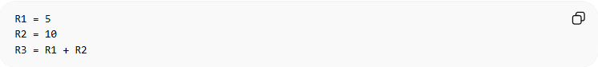
R1 = 5
R2 = 10
R3 = R1 + R2

2. Program Counter (PC)
Stores the address of the next instruction to be executed.
Example:
PC → 0x4010

3. Instruction Register (IR)
Stores the current instruction being executed by the CPU.

4. Memory Address Register (MAR)
Stores the address of the memory location that the CPU wants to access.

5. Memory Data Register (MDR)
Stores the data being read from or written to memory.

Example of Register Usage
# Source: AI Source: Provided by: [Data Path: Persons Table -> ID Column: 1, Name_En Column: Motasem Essam] -> From: [Chatgpt (GPT‑5 Mini)] on [12/10/2025]
Suppose a CPU performs:
C = A + B
Execution steps:
- Load A into Register R1
- Load B into Register R2
- CPU adds R1 + R2
- Store result in Register R3
Registers allow the CPU to perform operations extremely quickly.

2. CPU Cache

Definition
# Source: AI Source: Provided by: [Data Path: Persons Table -> ID Column: 1, Name_En Column: Motasem Essam] -> From: [Chatgpt (GPT‑5 Mini)] on [12/10/2025]
CPU cache is a small, high-speed memory located between the CPU and main memory (RAM).
It stores frequently used data and instructions so the CPU can access them faster.

Why Cache Is Needed
# Source: AI Source: Provided by: [Data Path: Persons Table -> ID Column: 1, Name_En Column: Motasem Essam] -> From: [Chatgpt (GPT‑5 Mini)] on [12/10/2025]
RAM is much slower than the CPU.
Without cache:
CPU → RAM → Data
With cache:
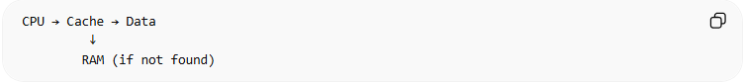
CPU → Cache → Data
↓
RAM (if not found)
This reduces the time needed to fetch data.

Cache Levels
# Source: AI Source: Provided by: [Data Path: Persons Table -> ID Column: 1, Name_En Column: Motasem Essam] -> From: [Chatgpt (GPT‑5 Mini)] on [12/10/2025]
Modern computers usually have multiple levels of cache.
L1 Cache
- Closest to the CPU
- Fastest
- Smallest (typically 32–128 KB)
L2 Cache
- Slightly slower than L1
- Larger (256 KB – several MB)
L3 Cache
- Shared between CPU cores
- Larger but slower than L1 and L2
- Several MB to tens of MB

Example of Cache Operation
# Source: AI Source: Provided by: [Data Path: Persons Table -> ID Column: 1, Name_En Column: Motasem Essam] -> From: [Chatgpt (GPT‑5 Mini)] on [12/10/2025]
- CPU requests data.
- Cache checks if data exists.
Cache Hit
CPU → Cache → Data found
Cache Miss
CPU → Cache → Not found → RAM
Cache greatly improves performance because programs often reuse the same data.

Memory Speed Hierarchy
# Source: AI Source: Provided by: [Data Path: Persons Table -> ID Column: 1, Name_En Column: Motasem Essam] -> From: [Chatgpt (GPT‑5 Mini)] on [12/10/2025]
From fastest to slowest:
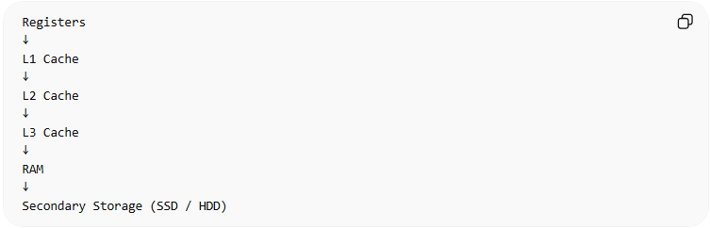
Registers
↓
L1 Cache
↓
L2 Cache
↓
L3 Cache
↓
RAM
↓
Secondary Storage (SSD / HDD)

Summary
# Source: AI Source: Provided by: [Data Path: Persons Table -> ID Column: 1, Name_En Column: Motasem Essam] -> From: [Chatgpt (GPT‑5 Mini)] on [12/10/2025]
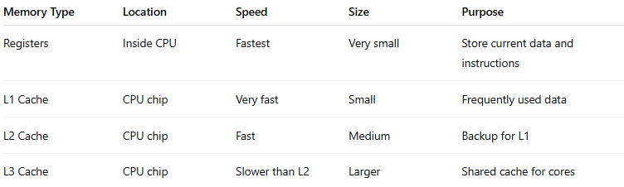
Memory Type | Location | Speed | Size | Purpose
Registers | Inside CPU | Fastest | Very small | Store current data and instructions
L1 Cache | CPU chip | Very fast | Small | Frequently used data
L2 Cache | CPU chip | Fast | Medium | Backup for L1
L3 Cache | CPU chip | Slower than L2 | Larger | Shared cache for cores

✅ In simple terms:
- Registers hold the data the CPU is using right now.
- Cache stores recently or frequently used data so the CPU doesn’t need to access slower RAM.

